Q1Write a program to print ASCII values of all backslash characters and white space on screen in following format :

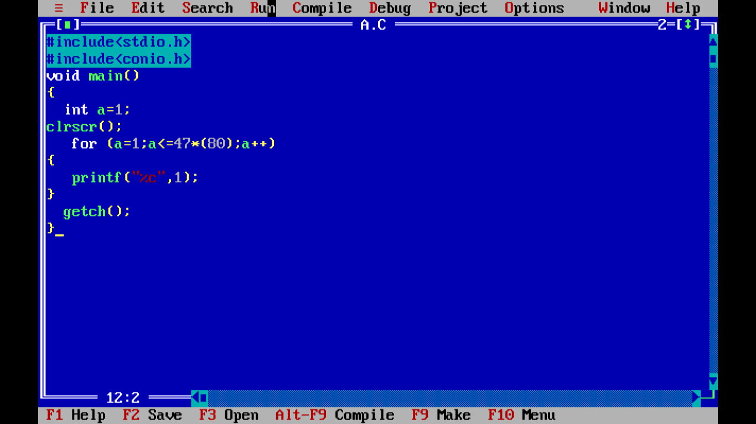



Q2 Explain different data types available in C?

In the [C programming language](http://en.wikipedia.org/wiki/C_(programming_language)), **data types** refers to an extensive system for declaring variables of different types. The language itself provides basic arithmetic types and syntax to build array and compound types. Several headers in the [standard library](http://en.wikipedia.org/wiki/C_standard_library) contain definitions of support types, that have additional properties, such as exact size, guaranteed.

|  |  |
| --- | --- |
| **Type** | **Explanation** |
| char | smallest addressable unit of the machine that can contain basic character set. It is an integer type. Actual type can be either signed or unsigned depending on the implementation. |
| signed char | same size as char, but guaranteed to be signed. |
| unsigned char | same size as char, but guaranteed to be unsigned. |
| short short int signed short signed short int | *short* signed integer type. At least in the [−32767,+32767] range,[[3]](http://en.wikipedia.org/wiki/C_data_types#cite_note-c99sizes-3) thus at least 16 bits in size. |
| unsigned short unsigned short int | same as short, but unsigned. |
| int signed int | basic signed integer type. At least in the [−32767,+32767] range,[[3]](http://en.wikipedia.org/wiki/C_data_types#cite_note-c99sizes-3) thus at least 16 bits in size. |
| unsigned unsigned int | same as int, but unsigned. |
| long long int signed long signed long int | *long* signed integer type. At least in the [−2147483647,+2147483647] range,[[3]](http://en.wikipedia.org/wiki/C_data_types#cite_note-c99sizes-3) thus at least 32 bits in size. |
| unsigned long unsigned long int | same as long, but unsigned. |
| long long long long int signed long long signed long long int | *long long* signed integer type. At least in the [−9223372036854775807,+9223372036854775807] range,[[3]](http://en.wikipedia.org/wiki/C_data_types#cite_note-c99sizes-3) thus at least 64 bits in size. Specified since the [C99](http://en.wikipedia.org/wiki/C99) version of the standard. |
| unsigned long long unsigned long long int | same as long long, but unsigned. Specified since the [C99](http://en.wikipedia.org/wiki/C99) version of the standard. |
| float | single precision floating-point type. Actual properties unspecified (except minimum limits), however on most systems this is the [IEEE 754 single-precision binary floating-point format](http://en.wikipedia.org/wiki/Single-precision_floating-point_format). This format is required by the optional Annex F "IEC 60559 floating-point arithmetic". |
| double | double precision floating-point type. Actual properties unspecified (except minimum limits), however on most systems this is the [IEEE 754 double-precision binary floating-point format](http://en.wikipedia.org/wiki/Double-precision_floating-point_format). This format is required by the optional Annex F "IEC 60559 floating-point arithmetic". |
| long double | extended precision floating-point type. Actual properties unspecified. Unlike types float and double, it can be either [80-bit floating point format](http://en.wikipedia.org/wiki/Extended_precision), the non-IEEE "double-double" or [IEEE 754 quadruple-precision floating-point format](http://en.wikipedia.org/wiki/Quadruple-precision_floating-point_format) if a higher precision format is provided, otherwise it is the same asdouble. See [the article on long double](http://en.wikipedia.org/wiki/Long_double) for details. |
|  |  |

Q.3Explain about C Tokens in brief.

n software engineering, a *token* is commonly understood to be a segment of textual input data, separated from similar segments by one or more separators. For example, all text that is not a space, tab or newline character in C language code makes a token.   
  
For example, this is a list of tokens, separated by semicolon: 123;321;ABC  
  
The term *token* is frequently used in context with lexical analysis, an early stage in language compilers and interpreters.   
  
A C compiler, for example, subjects the input (source code) to the preprocessor first. This removes all source code comments, makes "macro" substitutions and evaluates sections of conditional compilation.   
  
The preprocessor's results are then subject to lexical analysis, which consists of separating the source into tokens, then classifying them into categories such as "keyword," "decimal number," "variable reference," etc.

**C tokens:**

* C tokensare the basic buildings blocks in C language which are constructed together to write a C program.
* Each and every smallest individual units in a C program are known as C tokens.
* C tokens are of six types. They are,
  1. Keywords               (eg: int, while),
  2. Identifiers               (eg: main, total),
  3. Constants              (eg: 10, 20),
  4. Strings                    (eg: “total”, “hello”),
  5. Special symbols  (eg: (), {}),
  6. Operators              (eg: +, /,-,*)

**C tokens example program:**

Q4 Explain about backslash characters in C?

n C, all escape sequences consist of two or more characters, the first of which is the backslash, \; the remaining characters determine the interpretation of the escape sequence. For example, \n is an escape sequence that denotes a [newline](http://en.wikipedia.org/wiki/Newline) character. The remainder of this article focuses on C; other programming languages are likely to have different syntax and semantics.

Tab:’\t’ Character

New line Character ‘/n’

Black slash character ‘/b’

Carriage return’/r’

Audible return’\a’